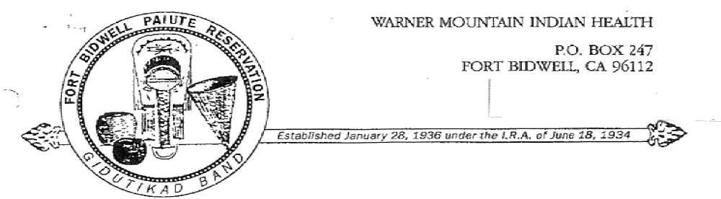

Job Announcement
Job Title: Community Health Representative
Supervisor: Clinic Manager / Clinic Nurse
Salary: DOE
Duration: Temporary / Full Time Hire

Statement of Performance: Under the direct supervision of the Clinic Nurse. The primary function of the position is to improve communications between the Indian community and the providers of health care and social services. Increase the Indian community’s access to already existing services, promote general health and assist with preventive and rehabilitative services and the delivery of comprehensive health services. Assist with the promotion of environmental health.

Position Summary:
- Identify American Indian families in the service area
- Make client home visits as assigned and scheduled
- Assist eligible clients in obtaining available social and health services
- Provide information regarding community resources to patient population
- Conduct informal meetings to define and explain possible solution regarding social and health problems
- Provide follow-up on the referrals made to outside providers
- Provide health education and counseling, coordinating it with dental, medical, and mental health services.
- Maintain current daily logs, required reporting forms utilizing CHR, PCC forms using SOAP format; maintain detailed current confidential records related to all parties contracted
- Attend training workshops, meetings, and seminars as directed by Clinic Nurse/ Clinic Manager
- Make visits to hospitals, skilled nursing facilities, convalescent homes, and nursing homes as needed.
- Arrange and support transportation as needed and directed.

12. Adjust work hours according to transportation schedule, i.e., come in 1-2 hours later on the days of prescription pick-ups, late afternoon appointments and long transport.
13. cooperate and work with Clinic staff, as assigned, to assist eligible clients.
14. Be available on the days the Clinic Physician is here, unless an emergency arises.
15. Arrange weekly meetings with Nursing Supervisor.
16. Maintain cleanliness and upkeep of transport vehicles, ensure that vehicles are cleaned upon return of each transport.
17. Perform other duties as assigned.

QUALIFICATIONS:
- Prefer experience in Human / Health Services
- Applicant must be IHS Community Health Representative trained
- Prefer applicant possesses a current Certified Nurses Certificate
- Must be a resident of the County of service
- Must agree to an annual physical examination and a TB skin test or X-Ray
- Computer experience a plus or the ability to learn
- Ability to interpret rules, regulations, and policies to explain them to other people, i.e., transporting minors-parent must accompany, etc.
- Ability to maintain confidentiality
- Ability to communicate with ithers and establish trusting relationships with patients
- Ability to serve as a roll model and be a member of the Indian community
- Current CPR and First Aid cards
- Current valid California Driver’s License and be insurable.

American Indian Preference
Qualified applicants who are of American Indian descent will be given hiring preference ( USC Section 45, U.S. Supreme Court, 06/17/74).
Applicants requesting Indian Preference must submit a copy of an official Bureau of Indian Affairs Certificate of Indian Blood, or other form, which clearly delineates affiliation and/or membership in a federally recognized Indian Tribe.

